Introduction to Programming II project log

Project title: | Coursework – Data Visualisation
Topic: | Week 15 and 16: Complete Heat Map and Feature Polishing
What progress have you made on this topic?
I added a legend and map instructions to the population density visualization to improve readability. I also polished several features, including resizing the waffle charts and repositioning the map instructions for better layout and clarity.

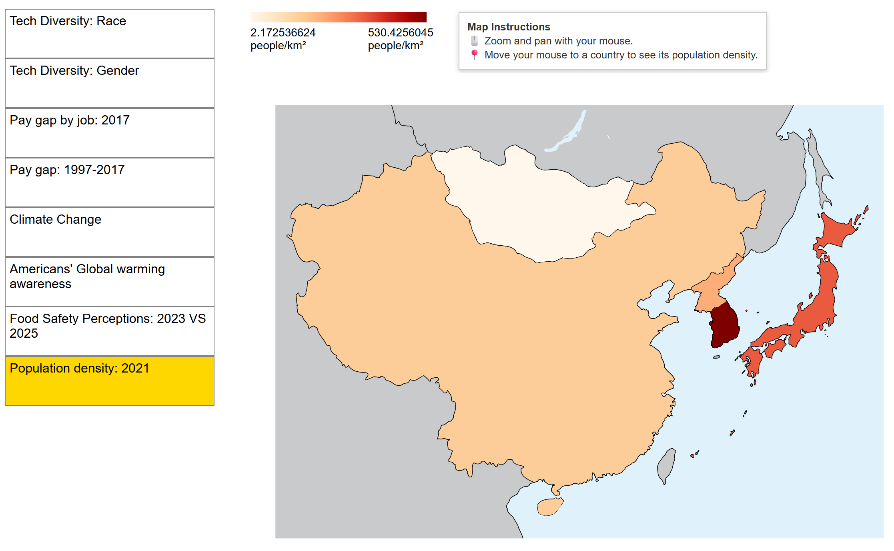
Pic 1: Legend and Map Instructions added

Feature polishing
- Enlarging the Waffle Charts
To increase visual clarity, I increased the size of the waffle charts.

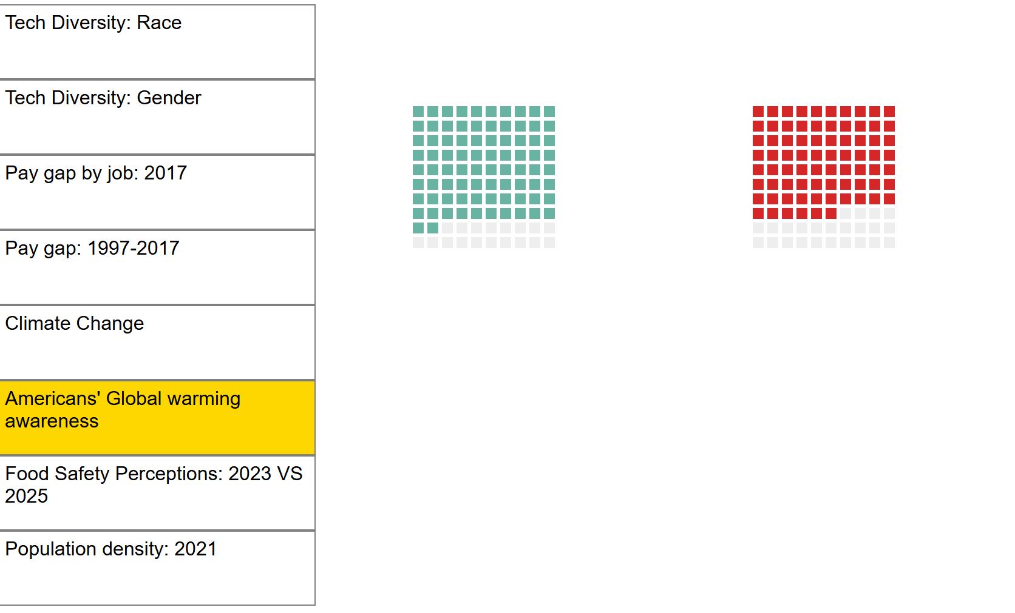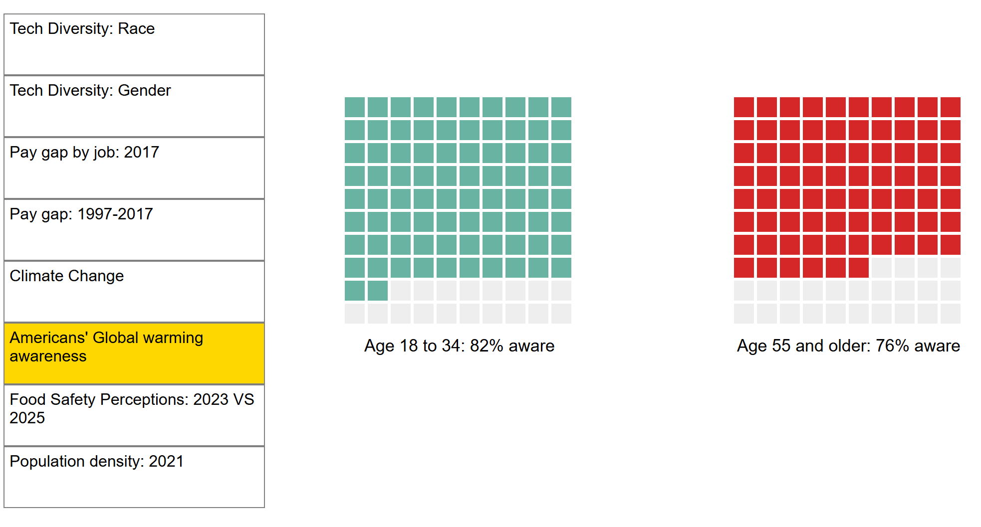
Pic 2: Initial Waffle Charts’ size Pic 3: Enlarged Waffle Charts

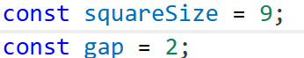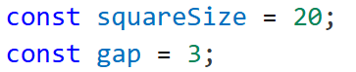
Pic 4: Code – Initial size setting Pic 4: Code – Final size setting
- Enlarging Hover Interaction – Heat Map
I increased the font size of the hover tooltip from 9px to 15px to make data easier to read and improve accessibility.

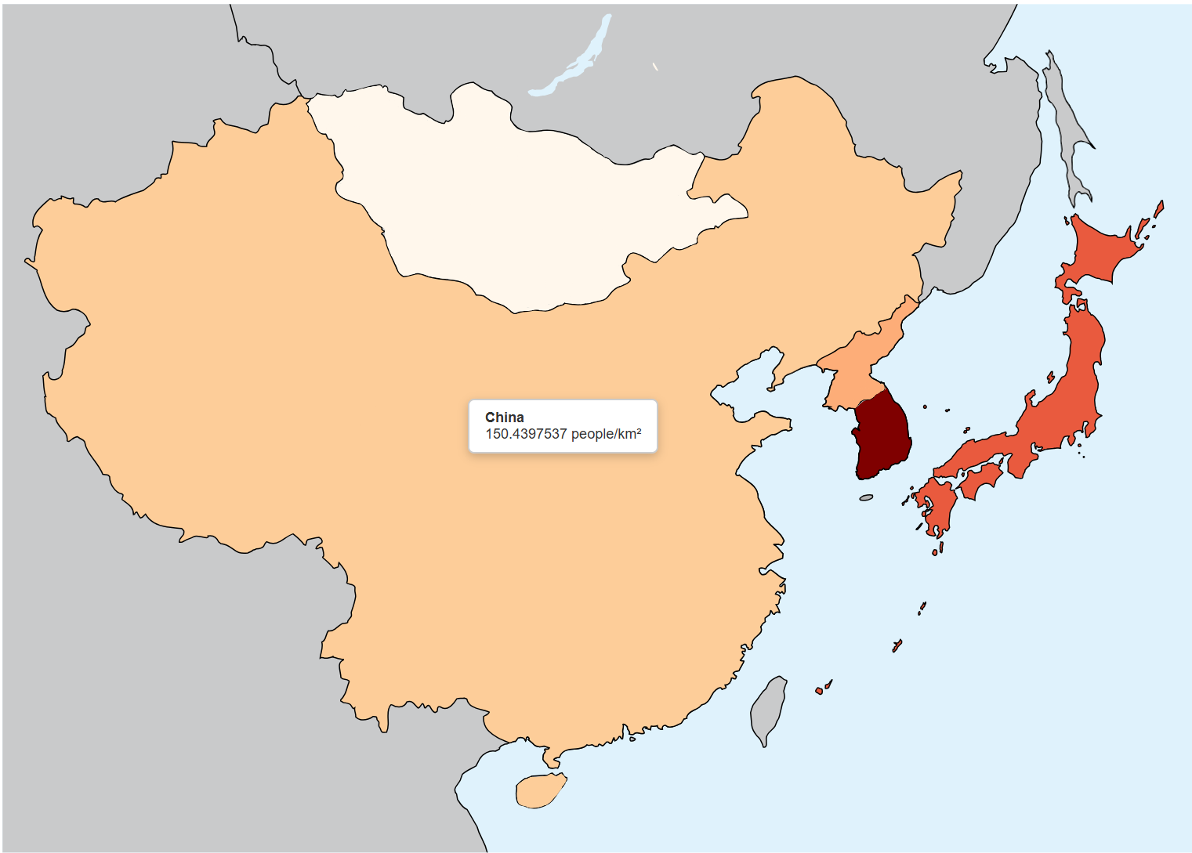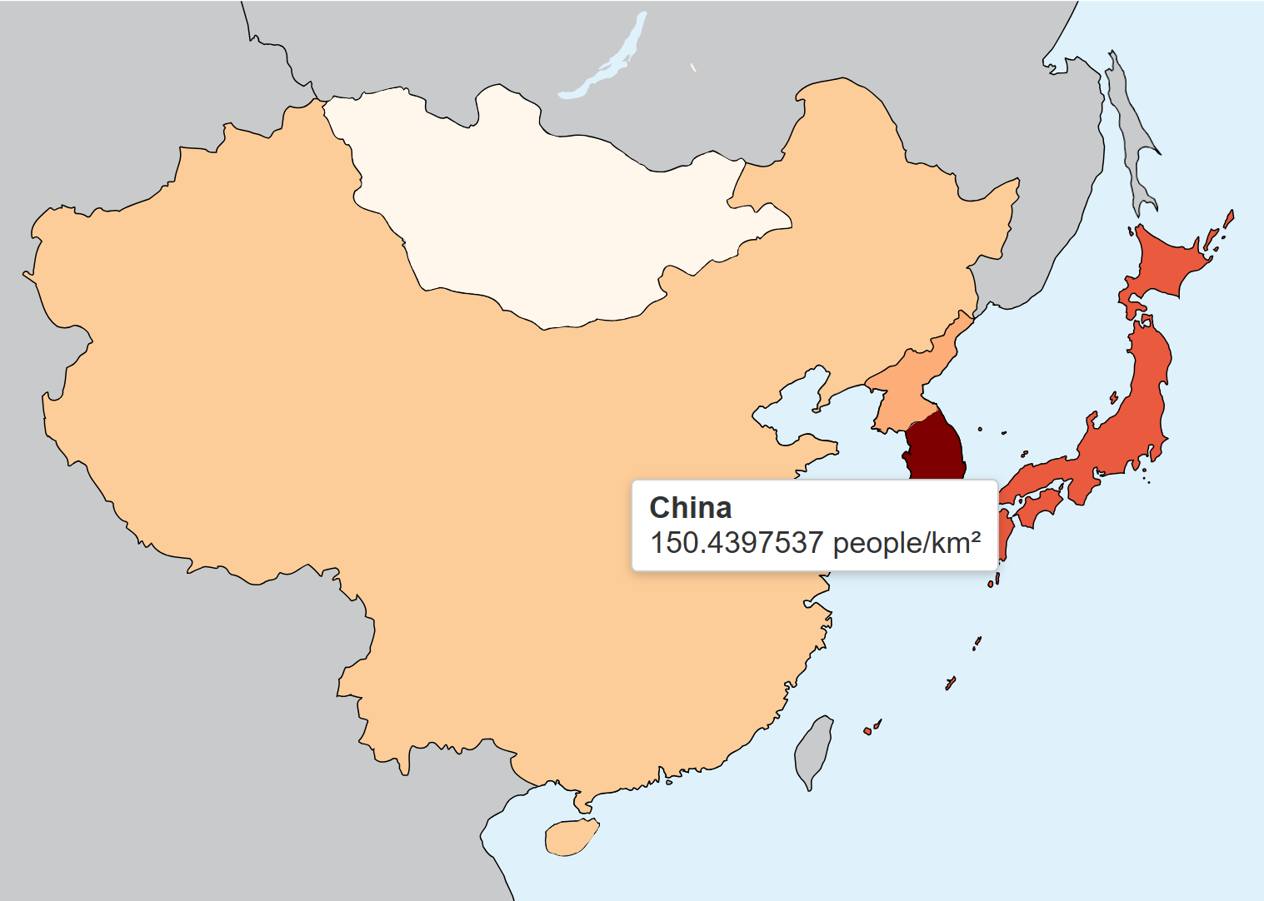
Pic 4: Initial font size of Hover Interaction Pic 5: Final font size of Hover Interaction

What problems have you faced and were you able to solve them?
- Map Instructions – wrong positioning
Problem: The Map Instructions were intended to be beside the legend. However, it appeared below the legend instead, and had a very long box (Pic 6)

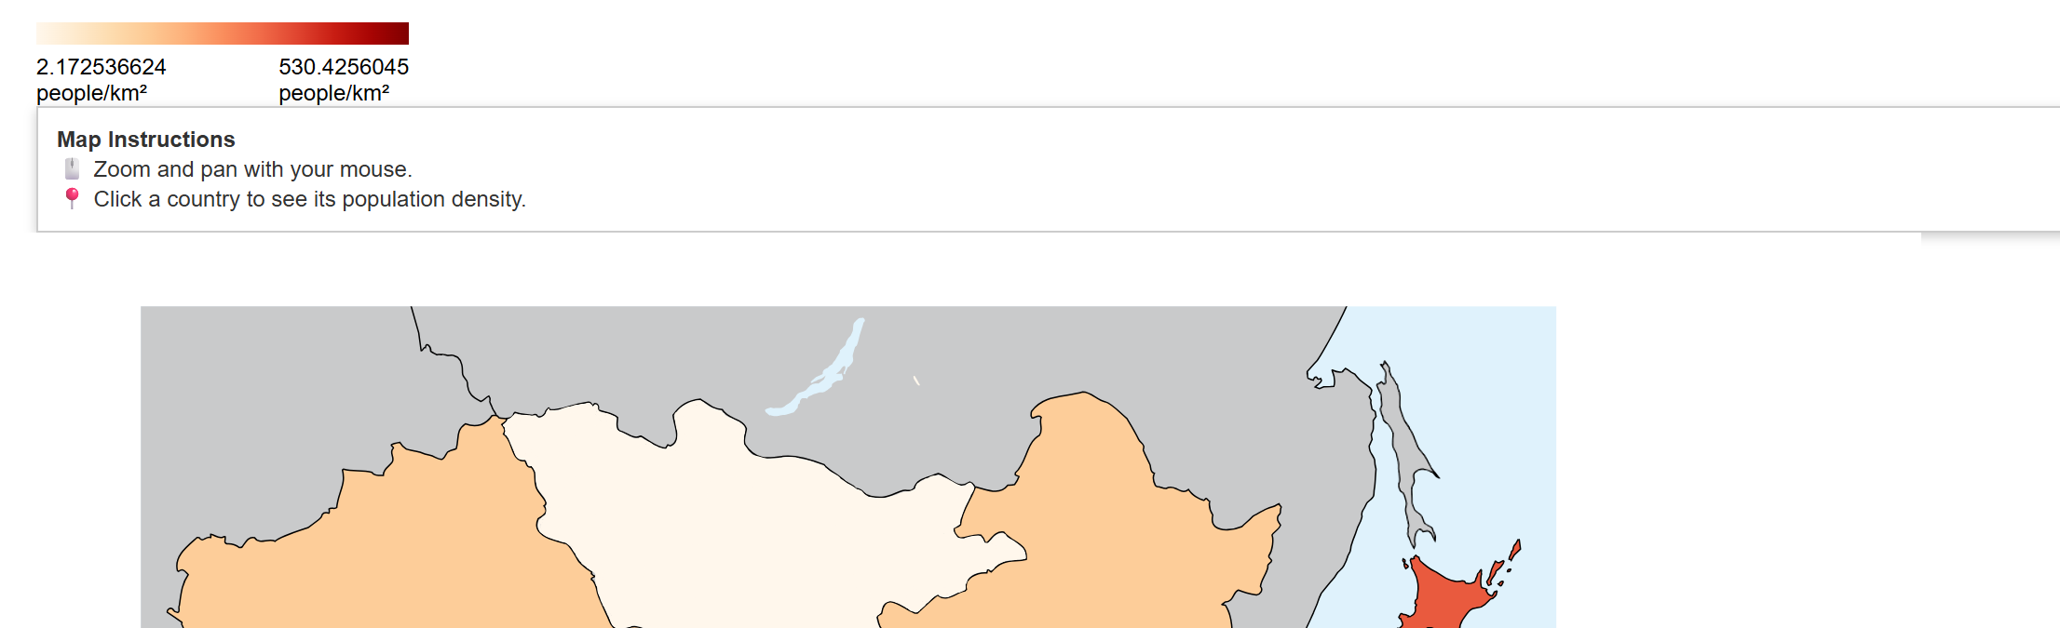
Pic 6: Map Instructions not positioned as intended

Solution: I added a legendWrapper variable to control alignment and position the Map Instructions as intended.

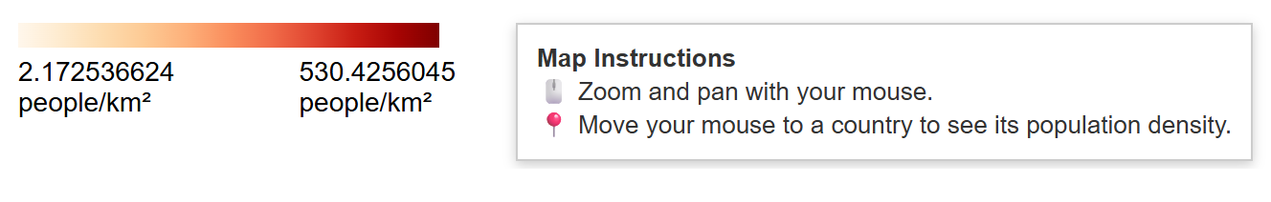
Pic 7: Map Instructions aligned

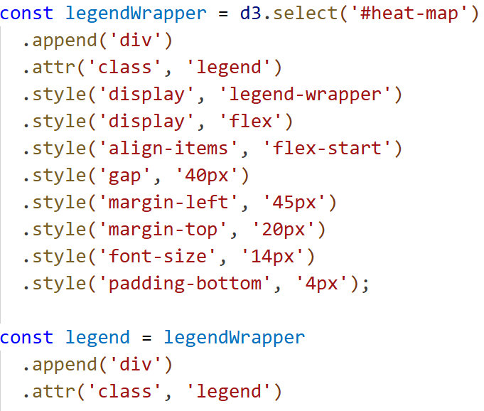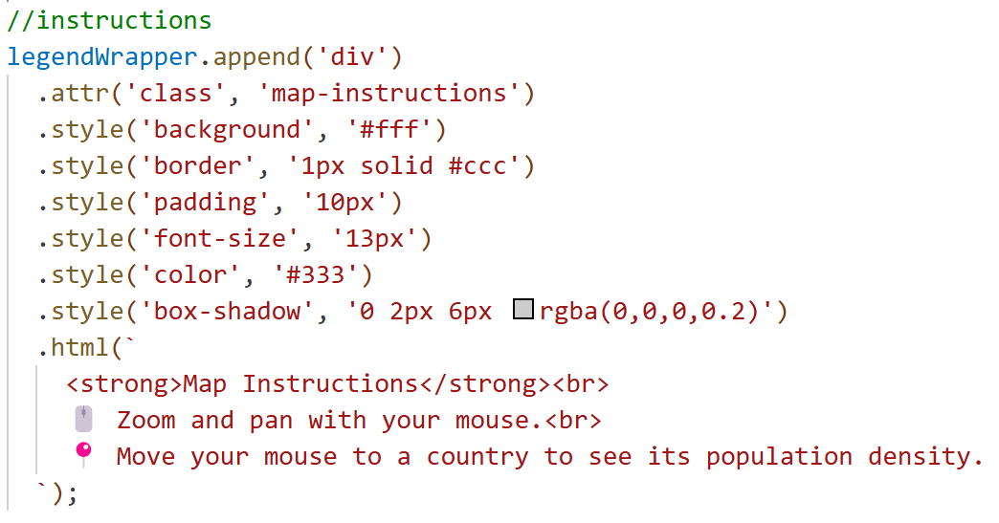
Pics 8 & 9: Code – Usage of legendWrapper to align Map Instructions

What are you planning to do over the next few weeks?
Over the next few weeks, my focus will be on:
- Debugging to ensure that the newly added legend, map instructions, and polished features do not introduce any errors.
- Stability and usability testing to validate performance and user experience across different scenarios.

Are you on target to successfully complete your project? If you aren’t on target, how will you address the issue?
I am on target to successfully complete my project. All planned extensions have been implemented, and minor checks have been conducted during development. No major bugs or errors have been identified so far. Once I complete a final general review, I will proceed with stability and usability testing to finalize the project.

